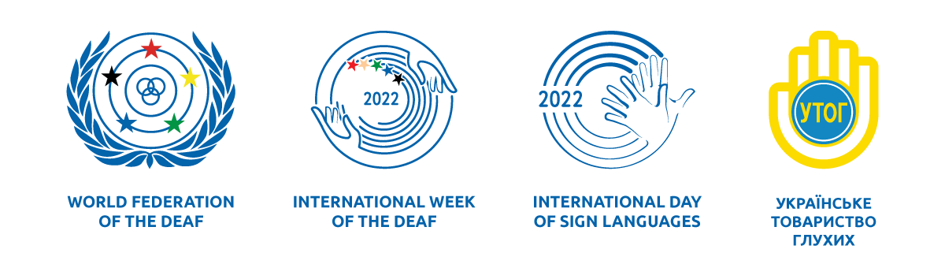

United Events of Ukrainian Society of the Deaf and Kyiv Professional College of Applied Sciences Dedicating to the International Week of the Deaf, September 19-25, 2022

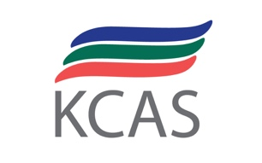

|  |  |
| --- | --- |
| Monday  September 19, 2022 | **Ukrainian Sign Language in Education**  International Сonference «Education of the Deaf during the War». Help from the world community. Let’s keep the educational order 24/7» (working languages: Ukrainian and American Sign Languages, Ukrainian, English)  16:00-17:30  <https://us02web.zoom.us/j/87066912371?pwd=djd6a3BXT3JYNTdhUUphUFlrbUE0QT09>  Meeting ID: 870 6691 2371  Passcode:1111 |
| Tuesday  September 20, 2022 | **Professional Opportunities of a Deaf Person**  «The Universe of Colors Created by Deaf Artists»  (translation in Ukrainian Sign Language)  11:30-12:50  <https://us02web.zoom.us/j/83692675575?pwd=Vm0yWVNEWFdxSmw4dlJDczdQOG1QQT09>  Meeting ID: 836 9267 5575  Passcode:1111  Career orientation event «Professional Prospects for Youth and Adults». Overview of professions (Sewing and Shoe Production; Graphic Design; Haute Couture Embroidery; Finance and Accounting), presentations, master classes, virtual tours (translation in Ukrainian Sign Language)  14:00-15:30  <https://us02web.zoom.us/j/87497539219?pwd=MkJXUWdLSzR2VkI4VkRWR01vWThMQT09>  Meeting ID: 874 9753 9219  Passcode:1111 |
| Wednesday  September 21, 2022 | **Barrier-Free Medicine and a Sign Language**  Practical seminar «Overcoming Barriers». Advices from psychological service  (translation in Ukrainian Sign Language)  13:00-14:00  <https://us02web.zoom.us/j/86211217187?pwd=VFBkWEU2R2N6VjBENk5kTHdGN3pUdz09>  Meeting ID: 862 1121 7187  Passcode:1111 |
| Thursday  September 22, 2022 | **Protection of Deaf People During the Crisis**  Seminar «Protection of Social Rights of the Deaf during the War» (Ukrainian Sign Language)  12:00-13:00  <https://us02web.zoom.us/j/89575772338?pwd=N1BVcUJRY29CUWw5Y0NrSmlUaE1lUT09>  Meeting ID: 895 7577 2338  Passcode:1111 |
| Friday  September 23, 2022 | **Sign Language Unites Us!**  Master class of studying Ukrainian and American Sign Languages «Communication in the World of the Deaf»  10:00-11:00  <https://us02web.zoom.us/j/87604483976?pwd=NjM3Y00wTWFrTEcyUEgwVzdzd3N6UT09>  Meeting ID: 876 0448 3976  Passcode:1111  Telecast «The Future is Ours!» for the students and schoolchildren from Ukraine and the US (working languages: Ukrainian and American Sign languages, Ukrainian, English)  16:00-17:30  <https://us02web.zoom.us/j/86939993891?pwd=ZDI5NUhvblRYSnFpSWhKYU40anJkdz09>  Meeting ID: 869 3999 3891  Passcode:1111 |
| Saturday  September 24, 2022 | **Intersectoral Communities of the Deaf** |
| Sunday  September 25, 2022 | **Nothing about the Deaf without the Deaf!**  A presentation of Kyiv Professional College of Applied Sciences – a 100-year-old educational institution with the largest contingent of deaf students in Ukraine within the Ukrainian Society of the Deaf panel discussion |